**COMP / IT 420 Spring 2021 Take Home Final Examination Compliment**

**Open: May 19th, 2021, 8:00am**

**Closed: May 20th, 2021, 8:00am (extension to May 21st if DASS)**

**Introduction**

This sheet is intended to be used as reference for the final examination. Due to the limitations of Canvas formatting, I’m providing copies of some of the questions here.

**Part 2: SQL**

1. Please construct a SQL query that returns the name and total number of credits each instructor taught in the Fall 2020 and Spring 2021 semesters if they taught more than four credits. Sort alphabetically by instructor name. Note that each section counts as a full course credit, so if someone teaches two sections of COMP420 and COMP420 is four course_credits, then that is eight total credits.

SELECT instructor_name, ***(1)***_____(***(2)***_______) FROM course

JOIN teaches using(***(3)***______)

JOIN ***(4)***______ using(sec_id)

JOIN instructor using(***(5)***_______)

WHERE (***(6)***_______ = ***(7)***_____ AND sec_year = 2020) ***(8)***_____ (sec_semester = "Spring" ***(9)***______ sec_year = 2021)

***(10)***______ instructor_id

***(11)***______ sum(course_credits) > ***(12)***______

ORDER BY ***(13)***_________ ***(14)***_____;

1. (8pts) The function validate_credits takes a course and a number of credits and checks to see whether the credit assignment aligns with the number of hours each course section is offered per week. For simplicity, each hour of class time is equal to a valid credit hour.

Please fill in the blanks in the validate_credits function below to ensure that courses have correct credits assigned.

TIMESTAMPDIFF takes an interval ("MINUTE", "SECOND", etc.), a start time and an end time and returns the number of units for that interval as an INT.

If a FLOAT value is equal to an INT value, e.g. 1.0 = 1, then MySQL will evaluate to true even though the types are different.

DELIMITER ***(1)*** ___

CREATE FUNCTION validate_credits (***(2)***_______ VARCHAR(7), credits ***(3)***_____)

RETURNS bool

BEGIN

-- declare variables to hold section total minutes per week

DECLARE sec_tot_week_minutes INT;

-- populate variable with section minutes per week

SELECT ***(4)***_____(sec_time_length) INTO sec_tot_week_minutes

FROM

(

SELECT TIMESTAMPDIFF(MINUTE, time_slot_start, time_slot_end) AS ***(5)***_________

FROM section

JOIN ***(6)***________ USING(time_slot_id)

WHERE ***(7)***________ = course_to_check

);

-- compare the input credit amount with the credit hours

-- computed from the section lengths in minutes

RETURN (credits = sec_tot_week_minutes / ***(8)***_______)

END //

**Part 3: Transaction Management**

Refer to the University Department Manager ERD for questions 1 and 2 below.

1. The transaction below enables a student (id 1234) enrollment in a specific course, "COMP520", section "001". In order to enroll the following conditions must be met:
   1. A student must be affiliated with the department of the course.
   2. A student's total credits cannot exceed 180.
   3. The course enrollment cannot exceed the capacity for the classroom.
   4. The total credits for the current semester (Spring 2020) for a student cannot exceed 18.
   5. A student must have taken the required prerequisite for COMP520.

(Note: If a condition has failed, a ROLLBACK call is expected.)

-- Declare temporary variables

DECLARE stu_tot_credits INT;

DECLARE stu_current_credits INT;

DECLARE stu_dept INT;

DECLARE comp_520_creds INT;

DECLARE comp_520_dept INT;

DECLARE class_capacity INT;

DECLARE current_class_capacity INT;

DECLARE ***(1)*** ______ VARCHAR(7);

-- Initiate the transaction

***(2)*** ____________;

-- Get the total number of current credits for the student

-- in the current semester

SELECT sum(***(3)***________) INTO stu_current_credits

FROM student JOIN enroll USING(student_id)

JOIN ***(4)*** _____________

JOIN section USING(sec_id)

WHERE ***(5)*** ___________________;

-- Check that current credits do not exceed condition D

IF ***(6)*** _______________ > 18 THEN

ROLLBACK;

END IF;

-- Get the total credits for student

SELECT student_tot_creds INTO ***(7)***__________ FROM student WHERE student_id = '1234';

-- Get the total course_credits for COMP520

SELECT course_credits INTO comp_520_creds FROM course WHERE course_id = 'COMP520';

-- Make sure that total credits do not exceed condition B

IF ***(8)*** ________________ + comp_520_creds > 180 THEN

ROLLBACK;

END IF;

-- Get the dept_ids to compare for condition A

SELECT dept_id INTO stu_dept FROM student WHERE student_id = '1234';

SELECT dept_id INTO comp_520_dept FROM course WHERE course_id = 'COMP520';

-- Compare dept ids

IF stu_dept != comp_520_dept THEN

***(9)***__________;

END IF;

-- Get class room capacity for section

SELECT class_capacity FROM classroom

JOIN section ON ***(10)*** ______________ AND classroom.class_building = section.sec_building WHERE ***(11)***______________;

-- Get current section number of enrolled

SELECT count(*) INTO ***(12)***___________ FROM enroll WHERE course_id = 'COMP520' AND sec_id = '001';

-- Compare capacities to check condition C  
IF current_class_capacity + 1 > ***(13)***___________ THEN

ROLLBACK;

END IF;

-- Get course prerequisite

SELECT course_prereq_id INTO prereq FROM course WHERE course_id = 'COMP520';

-- Check for condition E using a sub-query

IF prereq IN ( SELECT course_id

FROM enroll JOIN student USING(student_id)

WHERE student_id = ***(14)***___________) THEN

INSERT INTO enroll VALUES ('1234', ***(15)***______, '001');

***(16)*** ______

ROLLBACK;

END IF;

***(17)*** ________;

|  |  |
| --- | --- |
| TRANSACTION 1 | TRANSACTION 2 |
| START TRANSACTION | START TRANSACTION |
| validate_credits("COMP420", 4) |  |
| UPDATE course SET course_credits = 4 WHERE course_id = "COMP420"; | DECLARE comp_420_cred; |
|  | SELECT course_credits INTO comp_420_cred FROM course WHERE course_id = “COMP420”; |
|  | UPDATE student SET student_tot_creds += comp_420_cred WHERE student_id = 1234; |
| ROLLBACK |  |
|  | COMMIT |

**Part 5: NoSQL (12pts)**

1. (5pts) Fill in the following aggregate pipeline query to find the total number of employees working at companies that start with the letter “F”.

db.companies.aggregate([

{$***(1)***____: {***(2)***____: {$***(3)***_____: /^F/}}},

{$group: {

_id: “total_employees”,

total:{$***(4)***____: “***(5)***_________”}}}

])

1. (4pts) Fill in the following MapReduce to find the same information (total number of competitors for each company).

db.companies.mapReduce(***(1)***________, reduceComp,

{output: “total_comp_per_company”})

function mapComp(){

var i;

for( i = 0; i < this.***(2)***______.length; i++){

emit(***(3)***_____, 1);

}

}

function reduceComp(key, ***(4)***_____){

return Array.sum(values);

}

**Part 6: Concurrency**

Transaction Schedule for Precedence Graph:

|  |  |  |  |  |
| --- | --- | --- | --- | --- |
| *t* | T1 | T2 | T3 | T4 |
| 1 |  | Write(C) | Read(A) | Write(B) |
| 2 | Read(C) |  |  | Read(C) |
| 3 | Write(A) |  | Write(D) |  |
| 4 |  | Write(B) |  |  |

Transaction Schedule for Timestamp Ordering:

|  |  |  |  |
| --- | --- | --- | --- |
| *t-index* | T1 | T2 | T3 |
| 1 | Write(A) | Read(B) |  |
| 2 |  |  | Write(B) |
| 3 |  |  | Read(A) |
| 4 | Write(C) | Read(C) |  |
| 5 | Read(C) |  |  |
| 6 |  | Write(B) |  |

Time Stamp Ordering Status:

|  |  |  |  |  |
| --- | --- | --- | --- | --- |
| *t-index* | Transaction | Object | R-TS | W-TS |
| 1 |  |  |  |  |
| 1 |  |  |  |  |
| 2 |  |  |  |  |
| 3 |  |  |  |  |
| 4 |  |  |  |  |
| 4 |  |  |  |  |
| 5 |  |  |  |  |
| 6 |  |  |  |  |

According to the transaction schedule above, please fill in the table above by following a simple timestamp ordering. If a specific row of the transaction schedule results in a rollback, please put "X" in both the R-TS and W-TS cells for that row in the corresponding table.

The rules for simple timestamp ordering are as follows:

**R-TS** (Read Timestamp) is the transaction timestamp of last read

**W-TS** (Write Timestamp) is the transaction timestamp of last write

The timestamp of each transaction above is equal to its transaction number for convenience.

If a transaction wants to read an object A and:

TS(Ti) < W-TS(A)

  reject read and rollback Ti

TS(Ti) >= W-TS(A)

  read A and set R-TS(A) to equal max(R-TS(A), TS(Ti))

If a transaction wants to write to object A and:

TS(Ti) < R-TS(A)

  reject write and rollback Ti

TS(Ti) < W-TS(A)

  reject write and rollback Ti

Otherwise, execute write and set W-TS = TS(Ti).

**University Department Management (UDM) ERD and Business Rules**

The ERD below is an incomplete view of the UDM data model. Refer to Part 1 to complete it. Additional business rules are provided below, if you do not have enough information to know the exact connectivity, a reasonable guess is counted as correct.

The UDM manages department business, mainly enrollment and advising:

1. A COURSE can have a prerequisite, but only one.
2. A DEPARTMENT has many COURSEs and SECTIONs. A COURSE is only in one DEPARTMENT.
3. A SECTION takes place in a single CLASSROOM during a specific TIME_SLOT.

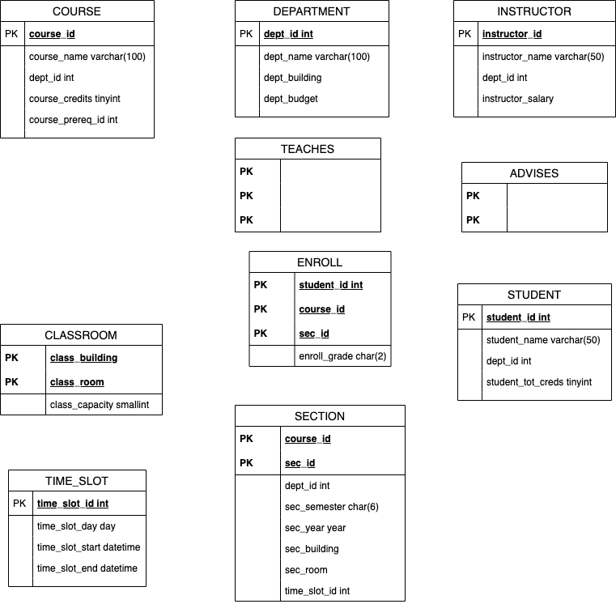

**Companies JSON Overview**

The companies.json document collection should be familiar to you from the labs. For the purposes of this examination only the following structure is needed.

Note that the “competitor” object is nested under the “competitor” key.

{

_id: ObjectId(“{some_id_string}”),

name: {company name},

permalink: {permanent unique key for company},

num_employees: {integer},

founded_year: {4 digit integer},

competitions: [

{

“name”: “{competitor name}”,

“permalink”: “{competitor company permalink}”

}, ...

]

}